CASE STUDY

**Background**

The dataset to be audited was provided which consists of a wide variety of intrusions simulated in a military network environment. It created an environment to acquire raw TCP/IP dump data for a network by simulating a typical US Air Force LAN. The LAN was focused like a real environment and blasted with multiple attacks. A connection is a sequence of TCP packets starting and ending at some time duration between which data flows to and from a source IP address to a target IP address under some well-defined protocol. Also, each connection is labelled as either normal or as an attack with exactly one specific attack type. Each connection record consists of about 100 bytes.

For each TCP/IP connection, 41 quantitative and qualitative features are obtained from normal and attack data (3 qualitative and 38 quantitative features) .The class variable has two categories:

* Normal
* Anomalous

Data basically represents the packet data for a time duration of 2 seconds.

1-9 Columns: basic features of packet (type 1)

10-22 columns: employ the content features (type 2)

23-31 columns: employ the traffic features with 2 seconds of time window (type 4)

32-41 columns: employ the host based features

C: Continuous data

D: Discrete data

|  |  |  |  |
| --- | --- | --- | --- |
| **Feature name** | **Variable type** | **Type** | **Description** |
| Duration | C | 1 | No. of seconds of the connection |
| Protocol_type | D | 1 | Type of protocol  E.g.: TCP,UDP ,ICMP |
| Service | D | 1 | Network service on the destination E.g.: http, telnet |
| Flag | D | 1 | Normal or error status of the connection |
| src_bytes | C | 1 | Number of data bytes from source to destination |
| dst_bytes | C | 1 | Number of data bytes from destination to source |
| Land | D | 1 | 1-connection is from the same host/port:  0-otherwise |
| Wrong_fragment | C | 1 | No. of ‘wrong’ fragments |
| Urgent | C | 1 | No of urgent fragments |
| Hot | C | 2 | The count of access to system directories, creation and execution of programs |
| Num_failed_logins | C | 2 | No. of failed login attempts |
| Logged_in | D | 2 | 1-successfully logged in  0-otherwise |
| num_compromised | C | 2 | No. of compromised conditions |
| Root_shell | C | 2 | 1-root shell is obtained;0 otherwise |
| Su_attempted | C | 2 | 1-‘su root’ command attempted;0 otherwise |
| Num_root | C | 2 | No .of root accesses |
| num_file_creations | C | 2 | Number of file creation operations |
| Num_shells | C | 2 | No of shell prompts |
| Num_access_files | C | 2 | No. of write ,delete and create operations on access control files |
| Num_outbound_cmds | C | 2 | No. of outbound commands in an ftp session |
| Is_hot_login | D | 2 | 1-the login belongs to the ‘hot’ list  0: otherwise |
| Count | C | 3 | No. of connections to the same host as the current connection in the past seconds |
| Srv_count | C | 3 | No of connections to the same host as the current connection in the past 2 seconds |
| serror_rate | C | 3 | % of connections that have ‘SYN’ errors to the same host |
| Srv_serror_rate | C | 3 | % of connections that have ‘SYN’ errors to the same service |
| Rerror_rate | C | 3 | % of connections that have ‘REJ’ errors to the same host |
| Srv_diff_host_rate | C | 3 | % of connections to different services and to the same host |
| Dst_host_count | C | 3 | No of connections to the same host to the destination host as the current connection in the past 2 seconds |
| Dst_host_srv_count | C | 3 | No of connections from the same service to the destination host as the current connection in the past 2 seconds |
| dst_host_srv_count | C | 3 | No. of connections from the same service to the destination host as the current connection in the past 2 seconds |
| Dst_host_srv_count | C | 3 | No. of connections from the same service to the destination host as the current connection in the past 2 seconds |
| Dst_host_same_srv_rate | C | 3 | % of connections from the same service to the destination host |
| Dst_host_diff_srv_rate | C | 3 | % of connections from the different services to the destination host |
| Dst_host_same_src_port_rate | C | 3 | % of connections from the port services to the destination host |
| Dst_host_srv_diff_host_rate | C | 3 | % of connections from the different hosts from the same service to destination host |
| Dst_host_serror_rate | C | 3 | % of connections that have ‘SYN” errors to same host to the destination host |
| dst_host_srv_serror_rate | C | 3 | % of connections that have ‘SYN’ errors from the same service to the destination host |
| Dst_host_rerror_rate | C | 3 | % of connections that have ‘REJ’ errors from the same host to destination host |
| Dst_host_srv_rerror_rate | C | 3 | % of connections that have ‘REJ’ errors from the same service to the destination host |

**Code Execution:**

## **1.Data Imputation:**

**1.1 Set working directory & Set Seed:**

setwd("E:/santosh_self/Working/DS/Imarticus/Imarticus/DSP23/3.Chapter(R)/3.12_Project 3 - Network Intrusion Detection using Decision Tree & Ensemble Learning in R")

#set the random number generation to a fixed value

set.seed(123)

rm(list = ls())

#Clean the workspace

gc()

*#Console:*

*#> setwd("E:/santosh_self/Working/DS/Imarticus/Imarticus/DSP23/3.Chapter(R)/3.9_Project 2 Default Modelling using SVM in R/Project 3 - SVM Credit Risk Analytics in R")*

*#> rm(list = ls())*

*#> gc()*

*# used (Mb) gc trigger (Mb) max used (Mb)*

*#Ncells 575388 30.8 1228650 65.7 1228650 65.7*

*#Vcells 2834692 21.7 8388608 64.0 3260580 24.9.0*

### **1.2 Read Dataset:**

# Read in the training datasets ad save it to object named “nw_train, nw_test,nw_valid”

nw_train<-read.csv("Network_Intrusion_Train_data.csv")

nw_test<-read.csv("Network_Intrusion_Test_data.csv")

nw_valid<-read.csv("Network_Intrusion_Validate_data.csv")

*#Environment*

*#25192 obs. Of 42 variables*

*#22544 Obs. Of 41 variables*

*#22544 Obs. of 42 variables*

*#Check the structure of dataset*

str(nw_train)

str(nw_test)

str(nw_valid)

*# Check the summary of datasets*

summary(nw_train)

summary(nw_test)

summary(nw_valid)

*# use the below function on the training dataset*

dim(nw_train)

head(nw_train)

str(nw_train)

summary(nw_train)

**1.3 Plot the relationship between discrete variables and the output variable**

Ideally, the proportion of events and non-events in the Y variable should approximately be the same. So, lets first check the proportion of classes in the dependent variables Gender

plot(nw_train$protocol_type, nw_train$class, main="Protocal Type vs Class",xlab="Protocol type", ylab="Class", col=c("red","lightgreen"))

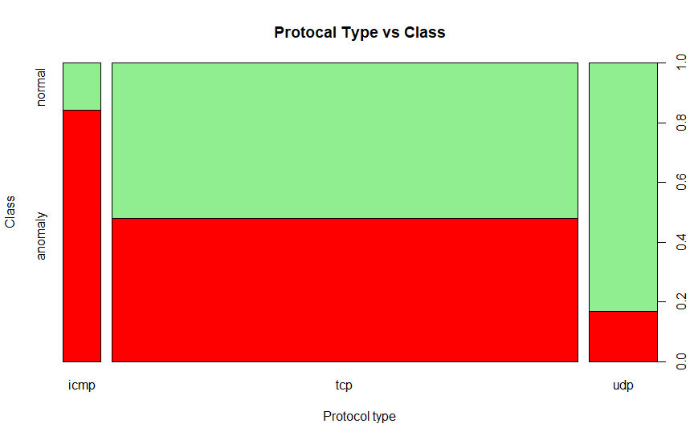

plot(nw_train$service, nw_train$class, main="Service vs Class",xlab="Service", ylab="Class", col=c("blue","grey"))

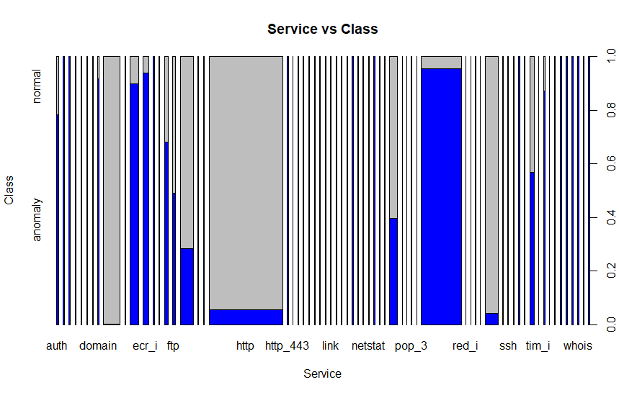

plot(nw_train$flag, nw_train$class, main="Flag vs Class",xlab="Flag", ylab="Class", col=c("brown","lightblue"))

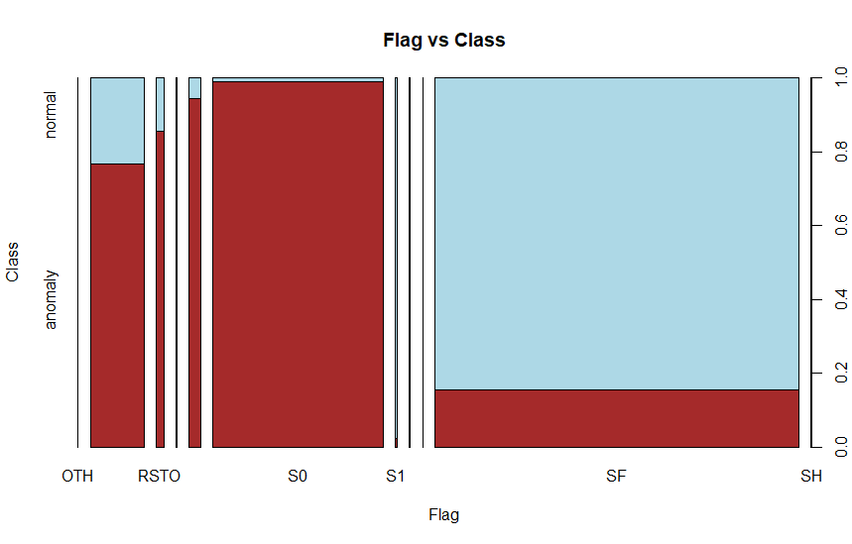

plot(as.factor(nw_train$logged_in),nw_train$class, xlab="logged In", ylab="Class", col=c("pink","lightyellow"))

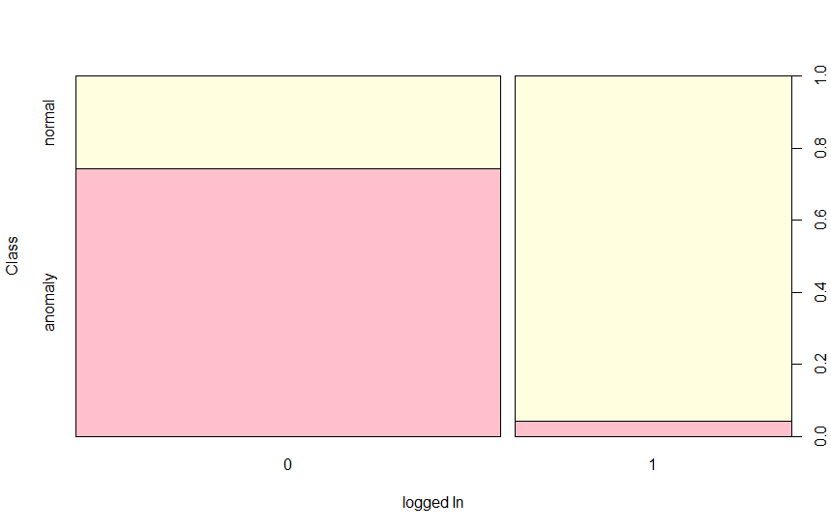

plot(as.factor(nw_train$is_host_login),nw_train$class, xlab="Is Host Login", ylab="Class", col=c("lightblue","yellow"))"))

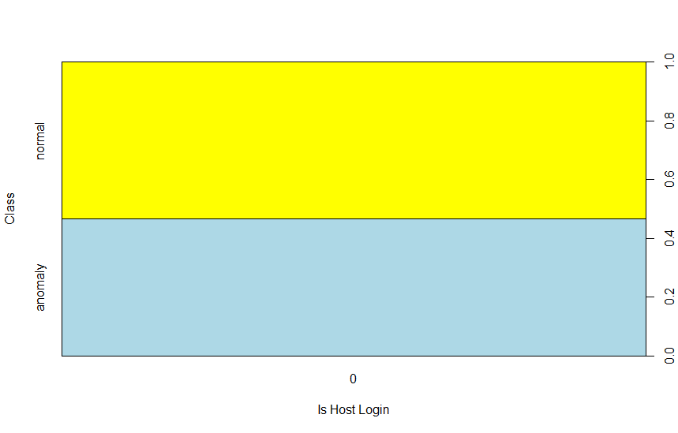

*#Create the cart model using rpart*

library(rpart)

cart_mod<-rpart(class~.,data=nw_train, method="class")

summary(cart_mod)

*#Global Environment*

*Large rpart(15 elements, 1.8Mb)*

*# Plotting Decision Tree*

plot(cart_mod,margin = 0.01)

text(cart_mod, use.n = T, pretty = T, cex=1)

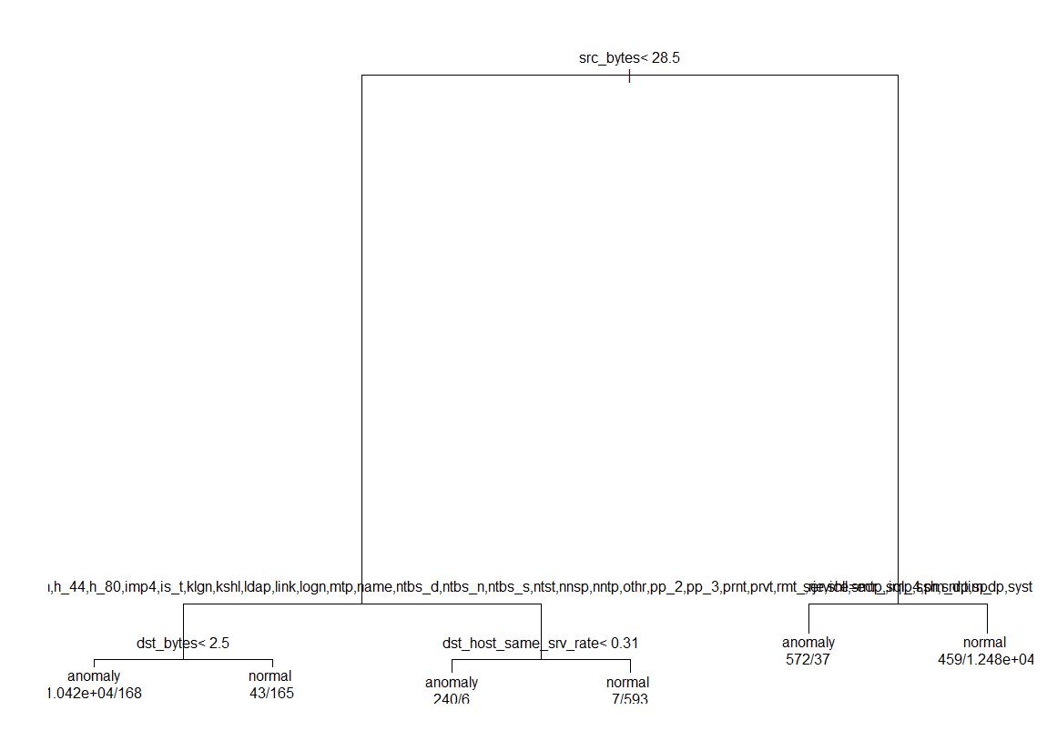

*#Lets do the predictions on the validation dataset using cart model*

*#Resolve error*

levels(nw_valid$service)=levels(nw_train$service)

*# Perform the prediction on the validation dataset using the model on decision tree*

pred_on_valid<-predict(cart_mod, newdata = nw_valid, type = "class")

pred_on_valid

table(nw_valid$class, pred_on_valid)

*# calculate the accuracy ratio*

accuracy_ratio_of_cart_mod<-(7672+9380)/(7672+331+5161+9380)

accuracy_ratio_of_cart_mod *#<-[1] 0.7563875 accuracy*

*#Console:*

*#> table(nw_valid$class, pred_on_valid)*

*# pred_on_valid*

*# anomaly normal*

*# anomaly 7672 5161*

*# normal 331 9380*

*#> accuracy_ratio_of_cart_mod<-(7672+9380)/(7672+331+5161+9380)*

*#> accuracy_ratio_of_cart_mod*

*#[1] 0.7563875*

*# Perform the prediction for test dataset*

levels(nw_test$service)=levels(nw_train$service)

pred_on_nw_test<-predict(cart_mod,newdata = nw_test, typr="class")

pred_on_nw_test

table(pred_on_nw_test)

*#Console:*

*#> table(pred_on_nw_test)*

*#pred_on_nw_test*

*#0.0116666666666667 0.0158640226628895 0.024390243902439 0.0354741479248783 0.0607553366174056 0.206730769230769*

*# 263 7066 154 12560 783 1718*

*# 0.793269230769231 0.939244663382594 0.964525852075122 0.975609756097561 0.984135977337111 0.988333333333333*

*# 1718 783 12560 154* *7066 263*

*# Alternate method of plotting*

library(rpart.plot)

library(RColorBrewer)

prp(cart_mod)

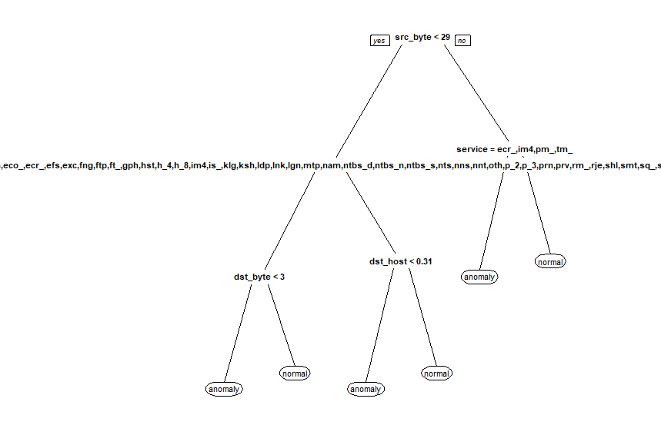

*#find out the cp parameter corresponding to the least cross validation error*

printcp(cart_mod)

*#Console:*

*#> printcp(cart_mod)*

*#Classification tree:*

*#rpart(formula = class ~ ., data = nw_train, method = "class")*

*#Variables actually used in tree construction:*

*#[1] dst_bytes dst_host_same_srv_rate service src_bytes*

*#Root node error: 11743/25192 = 0.46614*

*#n= 25192*

*# CP nsplit rel error xerror xstd*

*#1 0.832837 0 1.000000 1.000000 0.0067425*

*#2 0.045559 1 0.167163 0.167163 0.0036230*

*#3 0.029975 2 0.121604 0.121604 0.0031255*

*#4 0.019927 3 0.091629 0.091714 0.0027343*

*#5 0.010389 4 0.071702 0.071873 0.0024322*

*#6 0.010000 5 0.061313 0.065912 0.0023325*

**1.4Tree Model pruning**

The technique of setting constraint is a greedy-approach. In other words, it will check for the best split instantaneously and move forward until one of the specified stopping condition is reached

*#Prune the tree using cp parameter corresponding to the least cross validation error*

cart_mod_1<-prune(cart_mod, cp=0.01)

prp(cart_mod_1)



***# prediction on validation data using pruned tree***

pred_on_valid_1<-predict(cart_mod_1, newdata = nw_valid, type = "class")

table(pred_on_valid_1)

table(nw_valid$class,pred_on_valid_1)

accuracy_model_1<-(7672+9380)/(7672+331+5161+9380)

accuracy_model_1 ***#[1] 0.7563875***

***#Console:***

***#> table(pred_on_valid_1)***

***#pred_on_valid_1***

***#anomaly normal***

***# 8003 14541***

***#> table(nw_valid$class,pred_on_valid_1)***

***# pred_on_valid_1***

***# anomaly normal***

***# anomaly 7672 5161***

***# normal 331 9380***

***#> accuracy_model_1<-(7672+9380)/(7672+331+5161+9380)***

***#> accuracy_model_1***

***#[1] 0.7563875***

***# There is no change in model by default model using the least cross validation error and the corresponding cp parameters***

***# create a new model by using a different cp parameter***

cart_mod_2<-prune(cart_mod, cp=0.045559)

prp(cart_mod_2)

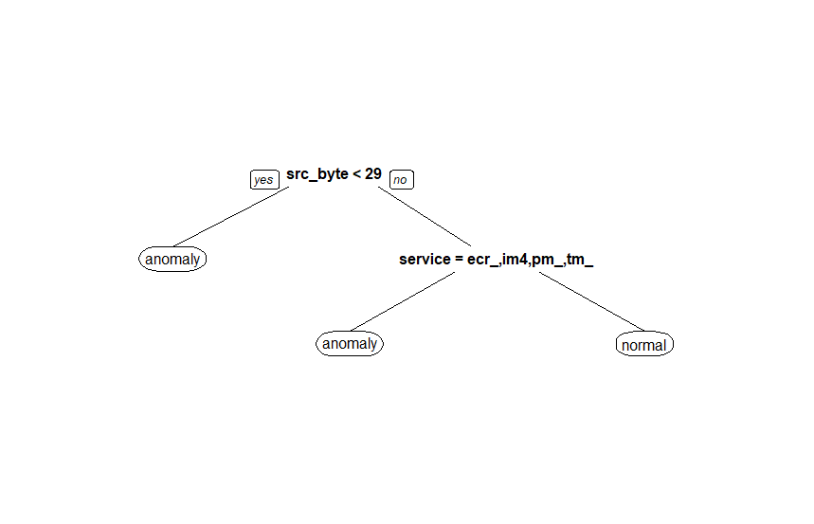

***# Prediction on validation dataset using model2***

pred_on_valid_2<-predict(cart_mod_2,newdata = nw_valid, type = "class")

table(pred_on_valid_2)

table(nw_valid$class, pred_on_valid_2)

accuracy_model_2<-(9468+9195)/(9768+516+3365+9195)

accuracy_model_2 ***#[1] 0.816976***

***#Console:***

***#> table(pred_on_valid_2)***

***#pred_on_valid_2***

***#anomaly normal***

***# 9984 12560***

***#> table(nw_valid$class, pred_on_valid_2)***

***# pred_on_valid_2***

***# anomaly normal***

***# anomaly 9468 3365***

***# normal 516 9195***

***#> accuracy_model_2<-(9468+9195)/(9768+516+3365+9195)***

***#> accuracy_model_2***

***#[1] 0.816976***

***# Prediction on test dataset using model2***

pred_on_nw_test_1<-predict(cart_mod_2,newdata = nw_test, type = "class")

pred_on_nw_test_1

table(pred_on_nw_test_1)

results<-data.frame(Duration=nw_test$duration, Protocal_type=nw_test$protocol_type, Service=nw_test$service,

flag=nw_test$flag, Predicted_class=pred_on_nw_test_1)

head(results,10)

***#>Console:***

***#> table(pred_on_nw_test_1)***

***#pred_on_nw_test_1***

***#anomaly normal***

***# 9984 12560***

***#> results<-data.frame(Duration=nw_test$duration, Protocal_type=nw_test$protocol_type, Service=nw_test$service,***

***+ flag=nw_test$flag, Predicted_class=pred_on_nw_test_1)***

***#> head(results,10)***

***# Duration Protocal_type Service flag Predicted_class***

***#1 0 tcp printer REJ anomaly***

***#2 0 tcp printer REJ anomaly***

***#3 2 tcp ftp_data SF normal***

***#4 0 icmp eco_i SF anomaly***

***#5 1 tcp supdup RSTO anomaly***

***#6 0 tcp http SF normal***

***#7 0 tcp rje SF normal***

***#8 0 tcp supdup SF normal***

***#9 0 tcp http SF normal***

***#10 0 tcp ftp SF anomaly***

**1.5 Random Forest**

Random Forest is considered to be a panacea of all data science problems. On a funny note, when you can’t think of any algorithm (irrespective of situation), use random forest!

Random Forest is a versatile machine learning method capable of performing both regression and classification tasks. It also undertakes dimensional reduction methods, treats missing values, outlier values and other essential steps of data exploration, and does a fairly good job. It is a type of ensemble learning method, where a group of weak models combine to form a powerful model.

It works in the following manner. Each tree is planted & grown as follows:

1. Assume number of cases in the training set is N. Then, sample of these N cases is taken at random but with replacement. This sample will be the training set for growing the tree.
2. If there are M input variables, a number m<M is specified such that at each node, m variables are selected at random out of the M. The best split on these m is used to split the node. The value of m is held constant while we grow the forest.
3. Each tree is grown to the largest extent possible and  there is no pruning.
4. Predict new data by aggregating the predictions of the ntree trees (i.e., majority votes for classification, average for regression).

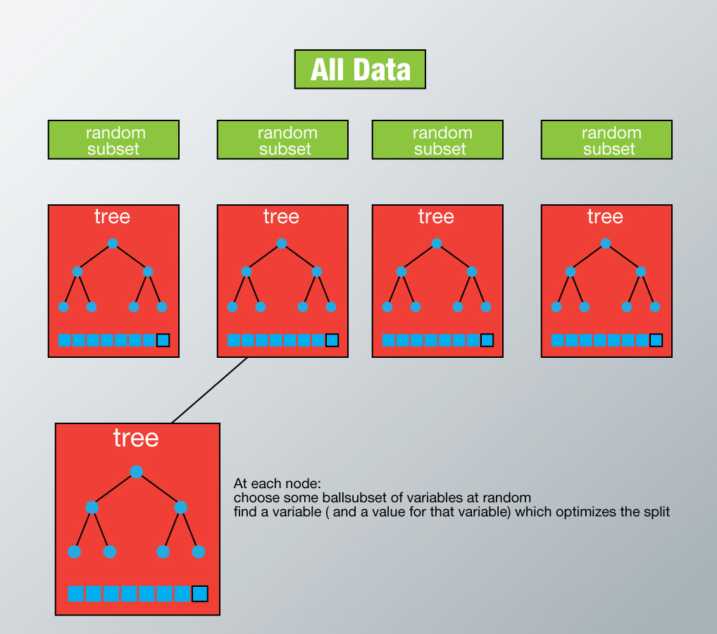

*#Random Forest (Ensemble learning)*

install.packages("randomForest")

library(randomForest)

levels(nw_test$service)=levels(nw_train$service)

ran_forest_mod<-randomForest(class~.,data = nw_train, method="class")

*#Random forest cannot handle more than 53 categorical predictors*

str(nw_train)

nw_train$service<-as.numeric(nw_train$service)

nw_test$service<-as.numeric(nw_test$service)

nw_valid$service<-as.numeric(nw_valid$service)

ran_forest_mod<-randomForest(class~.,data = nw_train, method="class")

*# Apply Random forest model on validation dataset*

pred_rnd_forest<-predict(ran_forest_mod,newdata=nw_valid,type="class")

*# Create the confusion matrix*

table(nw_valid$class, pred_rnd_forest)

*# Find the accuracy of random forest model*

ran_forest_mod_accuracy<-(8153+9441)/(8153+270+4680+9441)

ran_forest_mod_accuracy *#[1] 0.7804294*

*#Console:*

*# > Create the confusion matrix*

*#> table(nw_valid$class, pred_rnd_forest)*

*# pred_rnd_forest*

*# anomaly normal*

*# anomaly 8167 4666*

*# normal 274 9437*

*#> ran_forest_mod_accuracy<-(8153+9441)/(8153+270+4680+9441)*

*#> ran_forest_mod_accuracy*

*#[1] 0.7804294*

*# Identification of important variables*

varImpPlot(ran_forest_mod)

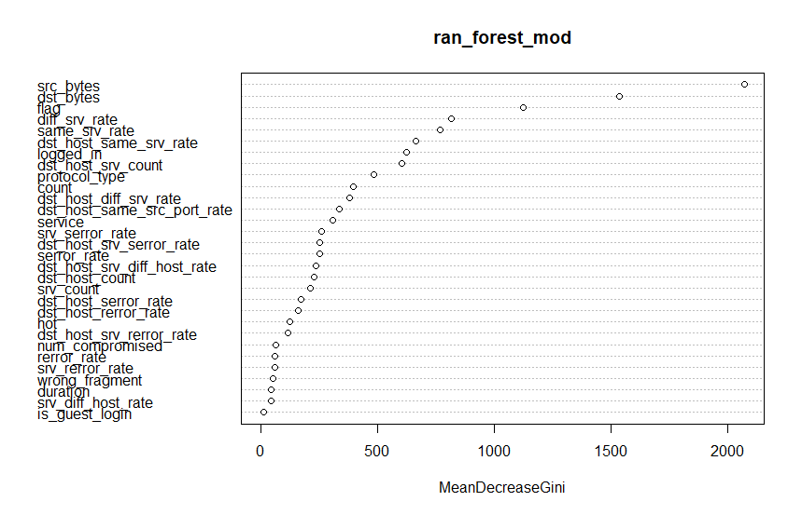

*# Do the prediction of Important variables*

pred_rnd_forest_test_data<-predict(ran_forest_mod, newdata = nw_test,type = "class")

table(pred_rnd_forest_test_data)

*# Store the results in new data frame called Network intrusion Random Forest*

Network_Intution_RF<-data.frame(Duration=nw_test$duration,Protocol_Type=nw_test$protocol_type,Service=as.factor(nw_test$service),Flag=nw_test$flag,Predicted_class=pred_rnd_forest_test_data)

head(Network_Intution_RF)

write.csv(Network_Intution_RF, "Network_Anamoly_Detection_Random_forest.csv",row.names = F)

*#Console:*

*#> table(pred_rnd_forest_test_data)*

*#pred_rnd_forest_test_data*

*#anomaly normal*

*# 8421 14123*

*#> head(Network_Intution_RF)*

*# Duration Protocol_Type Service Flag Predicted_class*

*#1 0 tcp 44 REJ anomaly*

*#2 0 tcp 44 REJ anomaly*

*#3 2 tcp 17 SF normal*

*#4 0 icmp 11 SF anomaly*

*#5 1 tcp 54 RSTO normal*

*#6 0 tcp 20 SF normal*

### **1.6 Conclusion**

Hence Decision tree model having good accuracy score as 81.69% and Random Forest model got an accuracy as 78%

Both the models are best fit to the case study.